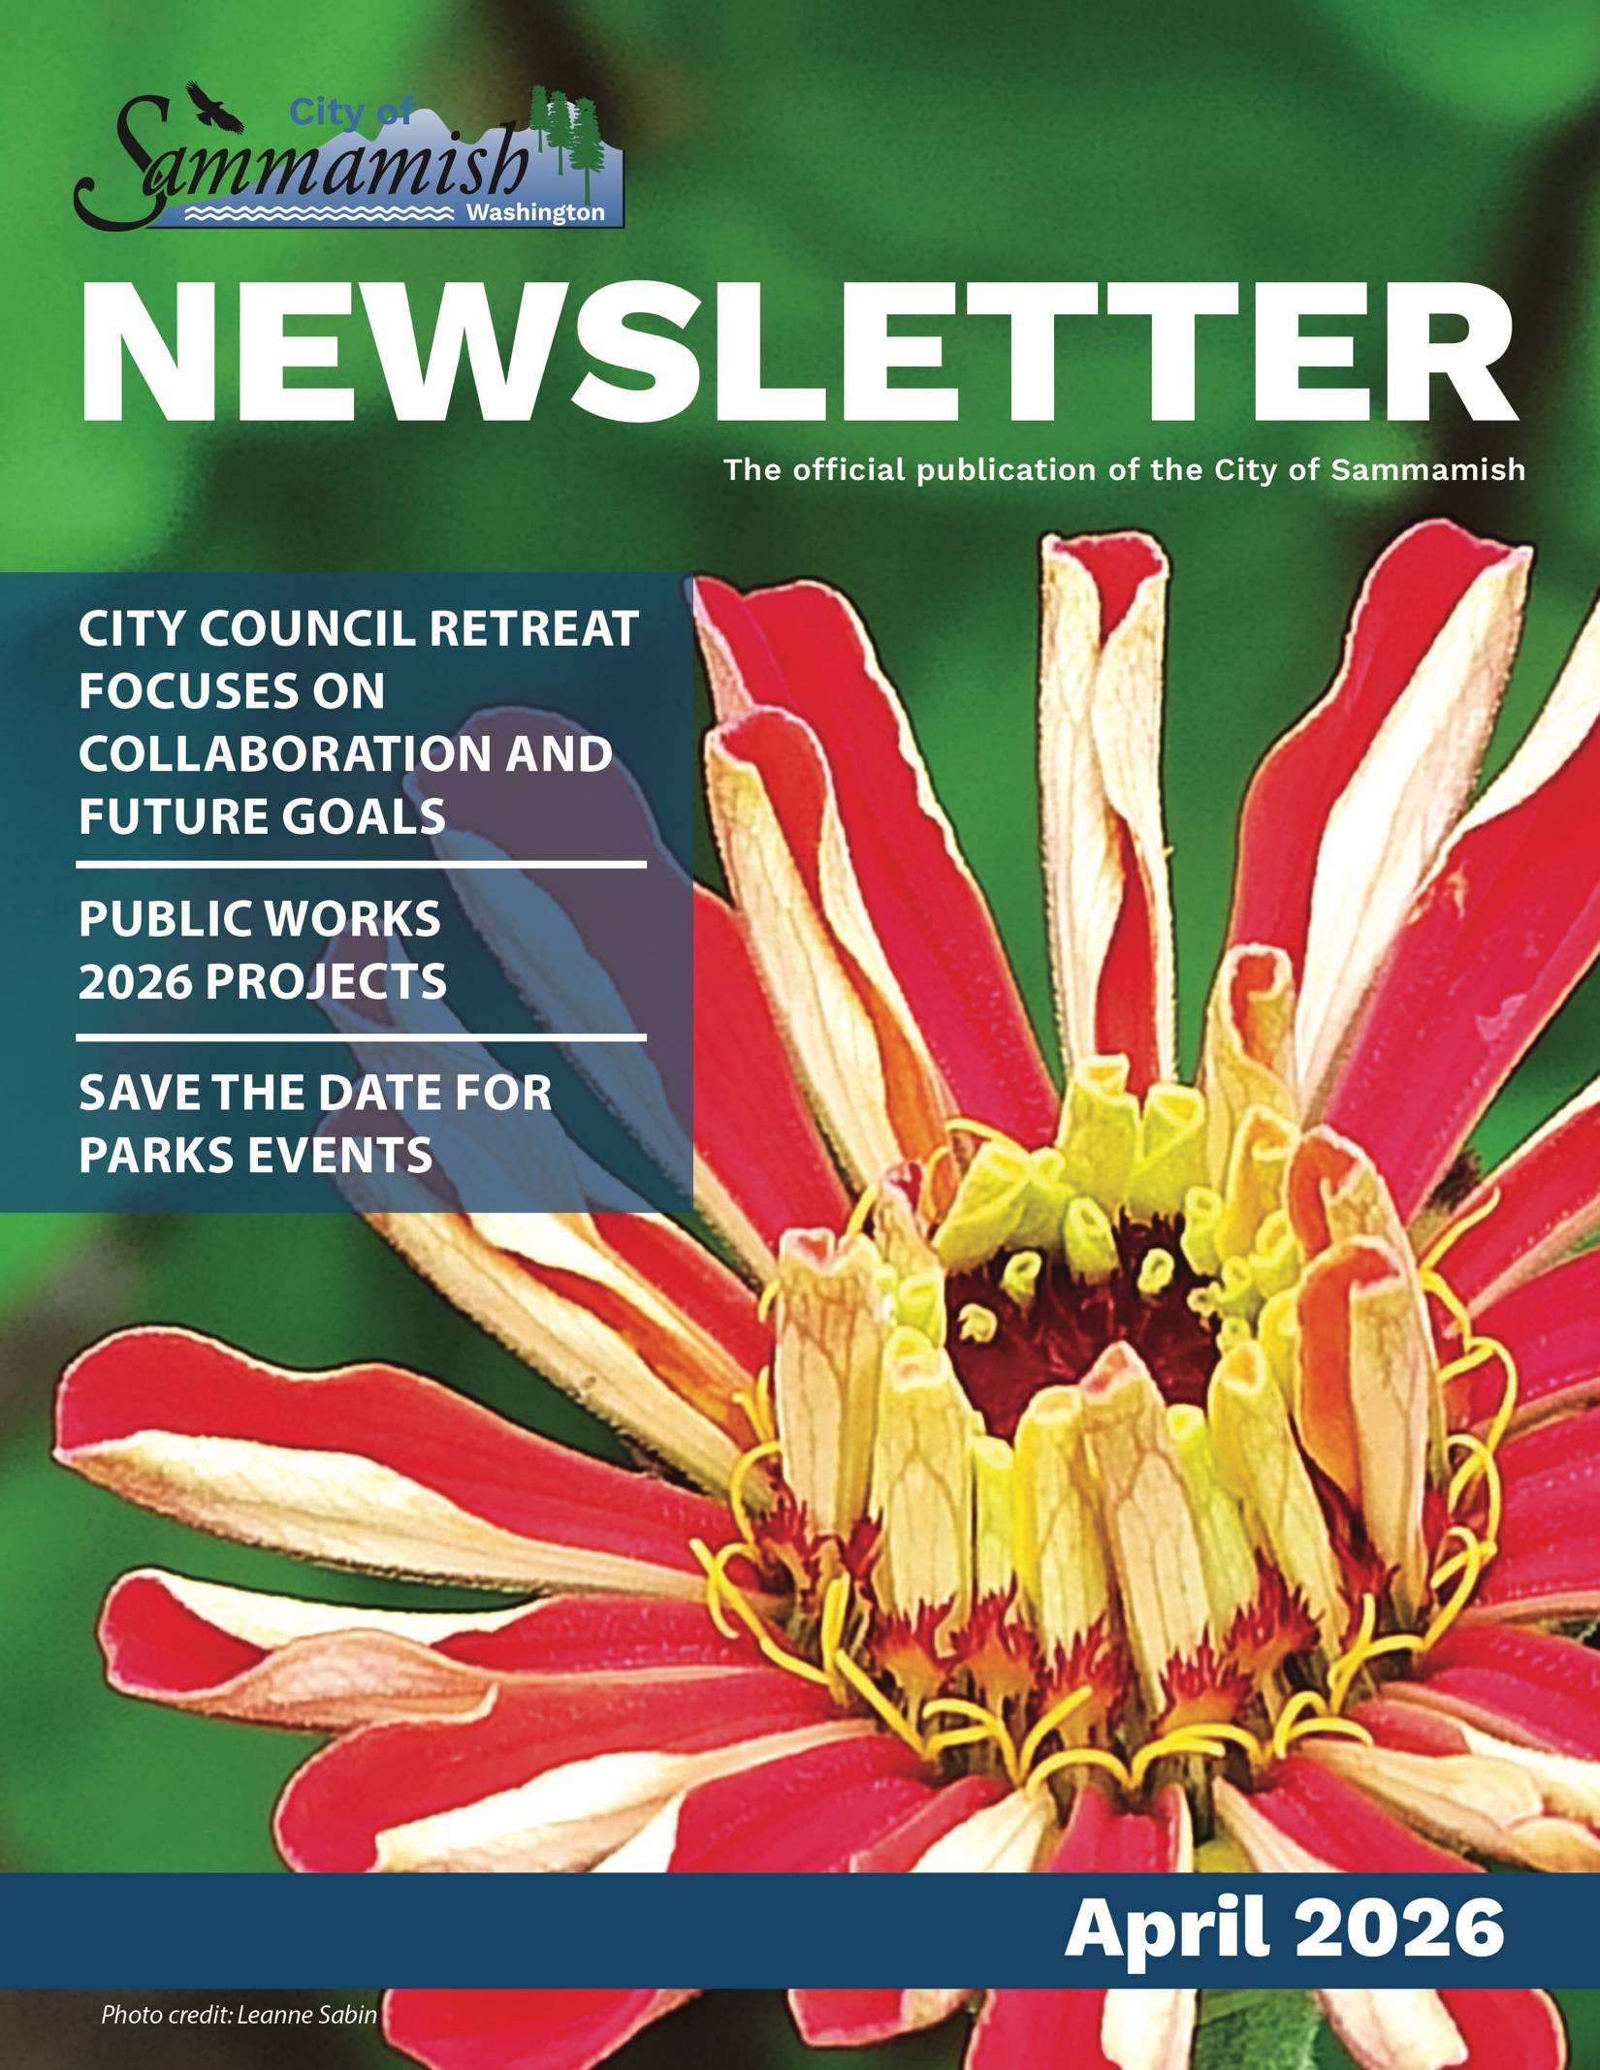Sammamish City Council
Council Meetings
Regular council meetings are held on the first Tuesday and third Tuesday of each month at 6:30 p.m., with a study session on the second Tuesday at 6:30 p.m. For more information, go to sammamish.us/citycouncil.
To contact the Sammamish City Council, email citycouncil@sammamish.us.

Coffee with Council
Join us for a cup of coffee and conversation. Coffee with Council happens the first Saturday of every month with rotating councilmember attendance. Meet them at 9:30 a.m. at Metropolitan Market in Sammamish. The councilmembers may be in the outdoor seating area depending on the weather conditions. Otherwise, you will find them in the upstairs seating area near the café. We hope to see you there!
Michael Boyer
Councilmember

Josh Amato
Mayor

Amy Lam
Councilmember

Roisin O’Farrell
Councilmember

Debbie Treen
Deputy Mayor

Kent Treen
Councilmember

Pamela Stuart
Councilmember

City Council retreat focuses on collaboration and future goals

Council Meeting Operating Agreements
- Assume good intent
- Seek to understand
- Demonstrate respect
- Establish agreed upon facts
- Be accountable
- Find common ground
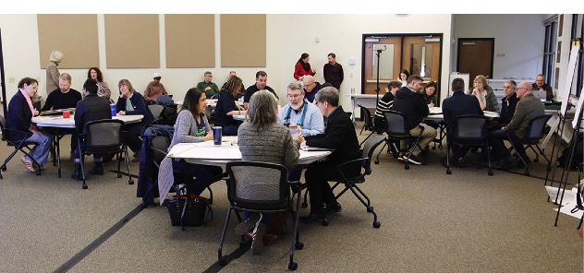
On Saturday, Feb. 7, the Sammamish City Council gathered at Building 120 for its annual retreat. The professionally facilitated session focused on building relationships, understanding roles and expectations, and discussing goals and priorities for the coming years. Several community members attended to hear the Council’s discussions and offer input during public comment.
The retreat kicked off with relationship building exercises and conversation around the culture the Council wanted to create. This work led to the Council writing a set of operating agreements for how they will work together during their business meetings. Discussion centered on accountability and respectful discourse, with a commitment to regular self-assessment.
The second half of the day centered on the Council’s goals and priorities, which are reviewed each year during the retreat and form the foundation for developing the next budget and work plan. The Council previously adopted seven goals to guide their work on topics such as the environment, safety, and transportation, along with definitions of success for each.
Councilmembers discussed keeping the existing goals with several updates to their content. In addition, there was consensus to work on updated definitions of success that shows how the City is making progress toward its goals. The updates to Council’s goals and definitions of success will provide staff with direction as the City begins building the 2027-2028 budget and work plan later this spring.
View the 2026 City Council Retreat on the City’s YouTube channel at: YouTube.com/Sammamish

Sammamish 101: planning teams shape the City
Do you know how your local government works? We’ve shared a lot of information about the role and responsibilities of various positions in local government. Now, we want to highlight some of the departments and divisions within the city and the work that they do.
Our long-range planning team includes four staff positions and our current planning team includes three staff positions – both groups are part of the Department of Community Development.
Current planning uses land use regulations to implement the City’s Comprehensive Plan. This team manages development reviews, land-use applications, and ensures building permits adhere to city codes.
To learn more about the work our current planning team does, visit our website: https://www.sammamish.us/government/community-development/current-planning/
Long-range planning closely works with the City Council and Planning Commission to prepare and maintain the plans and regulations that help shape the City, including the City’s Comprehensive Plan and the Sammamish Development Code. They also create tools and plans that inform City work plans, such as the Housing Diversification Toolkit, the Climate Action Plan, and the Urban Forest Management Plan.
To learn more about the work they do visit: https://www.sammamish.us/government/community-development/long-range-planning/

When are permits required?
- 228th Banner reservations
- Electrical work
- Fire service (ex. Fire sprinklers, fireworks)
- Conditional use (allows a useage not in the current zoning)
- Right-of-way use
- Tree removal
This is not an exhaustive list and more information about permits can be found online.
To learn more: https://bit.ly/4biy9Vo

Walk-in, in person Permit Center Hours at City Hall
Monday 9 a.m. – 12 p.m.
Wednesday 1 p.m. – 4 p.m.
Friday 9 a.m. – 12 p.m.
The community can also make an appointment for service, for more info visit: https://bit.ly/4sT9ZYM

Private stormwater system inspections: protecting our community and waterways
The City’s private stormwater system inspection program has been in place since before Sammamish was incorporated. For many years, King County conducted inspections on the City’s behalf, until Sammamish hired dedicated staff in 2010 to take on this work. City inspectors review nearly 200 privately owned stormwater systems each year to ensure they meet local requirements and continue to function properly.
Stormwater systems collect and manage runoff before it reaches our streams, lakes, and Lake Sammamish. These privately owned systems often include stormwater ponds, swales, ditches, pipes, and catch basins. When properly maintained, they help protect homes and buildings from flooding while also improving water quality.
Property owners are responsible for keeping their stormwater systems clean and in good working order. Failure to maintain a system may result in penalties, so staying informed and proactive is essential.
To learn more about inspection requirements and maintenance responsibilities, please visit https://www.sammamish.us/npdes-stormwater-permit/. You can also reach out to the Stormwater Division by email stormwateradmin@sammamish.us.

Honoring City volunteers
We hosted our annual Volunteer Appreciation event, celebrating the incredible individuals who give their time and talent to our community, Feb. 26.
Councilmembers in attendance included Mayor Amato, Deputy Mayor Treen, Councilmember Lam, Councilmember O’Farrell, and Councilmember Boyer.
Thank you to all of our volunteers who help keep Sammamish beautiful and community-focused.
Award Highlights:
Volunteer of the Year: Anna Yorba, Master Steward and Parks & Recreation Commissioner Omnipresent Helper Award: Steve Christensen of the Sustainability Commission

Legacy Awards (5+ Years of Service):
Anna Yorba, Gary Reum, Jan Bird, Janelle Deutsch, Lena Wegner, Linda Shepherd, Mark Baughman, Mike Bresko, Sarah Cheng, Sharon Steinbis, Steve Marple, and Uma Coimbature.
Sammamish Volunteer Service Awards: 42 volunteers were recognized (16 Bronze, 16 Silver, 10 Gold) based on hours served.

Public Works 2026 construction projects
This year, the City will continue work on several key projects to help maintain and improve our local roads, sidewalks, and culverts.

Louis Thompson
Construction on the Louis Thompson Road Tightline Project is nearly complete. The final pavement overlay will take place this spring. Once paving is complete, crews will install final striping and complete roadway markings. Improvements made include a new sidewalk connection, upgraded traffic signal, a new storm drainage system, new retaining walls, and a bike lane.
To read more about this project visit:
www.sammamish.us/projects/louis-thompson-tightline/

32nd Street Sidewalk
The work on this project includes the construction of a new 630-foot-long sidewalk, bike lane, and planter strips along the north side of the street, between 241st Avenue Southeast to the west, and 244th Avenue Southeast to the east. The sidewalk will provide residents with a safe path to nearby facilities, while minimizing the impact on the environment. The project will also include new curb & gutter, driveway entrances, roadway striping, retaining walls, and a storm drainage conveyance system.
To read more about this project visit:
www.sammamish.us/projects/se-32nd-street-sidewalk-project/

Southeast 6th Street
The Southeast 6th Street Improvements consist of the construction of a new public street that will run along the north end of Sammamish Commons Park, between 222nd Place Southeast and 224th Avenue Southeast. The new street shall provide usable space for pedestrians, bicyclists, and vehicles.
The north half of the street will be designed and constructed by private developers. The City will manage the design and construction of the south half of the street. The estimated design and construction completion dates are June 2026 and November 2026.
To learn more visit:
www.sammamish.us/projects/se-6th-street-improvements/

Loree Estates Outfall
The Sammamish Loree Estates Outfall Diversion Project will reroute stormwater flows from an unstable, actively eroding outfall located within an existing easement behind 20028 Southeast 19th Street to a new closed conveyance system. The move will reduce erosion risks, enhance public safety, and strengthen long-term infrastructure by relocating the outfall from a narrow drainage easement between private properties.
To learn more, visit: www.sammamish.us/projects/loree-estates-outfall-diversion/

Stormwater retrofit
Demery Hill – Water Quality Improvements: The City is moving forward with a water quality treatment upgrade at Demery Hill, located near the Northeast 8th Street cul-de-sac. The project includes a new water quality vault that treats stormwater runoff and is designed to provide enhanced treatment. The city is aiming to start construction this summer.
Southeast 20th Street & 228th Ave Southeast – Stormwater Facility Improvements: The City is advancing stormwater upgrades in the 228th Ave Southeast area. This project focuses on improving stormwater management by updating existing facilities to better manage runoff and enhance water quality performance.

2026 Overlay Project
The City of Sammamish will resurface pavement on local streets as staffing allows. Some of the streets considered include:
- Issaquah-Pine Lake Road Southeast from 228th Avenue Southeast to 234th Avenue Southeast
- Southeast 29th Street from 228th Avenue Southeast to 226th Avenue Southeast
- 223rd Avenue Southeast from Southeast 20th Street to the north end of the road
- 220th Avenue Southeast from Southeast 16th Place to the south end of the road
Work includes removing the top layer of existing asphalt, subbase repairs, installing new pavement, and new roadway markings. Adjacent pedestrian curb ramps will also be upgraded to meet ADA compliance.
To learn more: https://www.sammamish.us/projects/2026-pavement-overlays/

George Davis Creek
The work on George Davis Creek is expected to start this spring and go through to late fall 2026. Work to restore salmon and riparian habitat along the lower reaches of George Davis Creek is a core part of this project. In partnership with King County, this work also includes:
- Replacement of non-fish-passable culverts at East Lake Sammamish Shore Lane Northeast and the King County East Lake Sammamish Trail with new 17-foot box culverts
- Installation a short-span bridge to replace the non-fish-passable culvert under East Lake Sammamish Parkway
To learn more: https://www.sammamish.us/news/george-davis-creek-fish-passage-project-project-update/
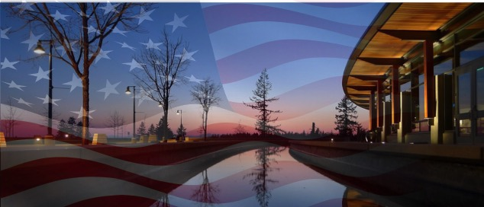Refugee and Immigrant Resources
In January, the Sammamish City Council reaffirmed its commitment to every person who calls Sammamish home by launching a new City webpage focused on resources for local immigrants and refugees.
Sammamish Police are dedicated to serving and protecting the public. They do not ask for proof of immigration status, nor do they enforce federal immigration laws. Their mission is to keep every resident safe, respond to emergencies, and support the well-being of the community.

Council Statement
“The Sammamish City Council reaffirms our unwavering commitment to every person who calls Sammamish home. Our community is made stronger by the diversity of backgrounds, cultures, and life experiences that residents bring to this city. No matter your citizenship status, birthplace, or the path that brought you here, you are a valued member of our community. The City remains committed to ensuring that every resident feels safe seeking help, accessing services, participating in civic life, and being part of the fabric of this city.
We want to be clear about the role of our local government and public safety agencies. The City of Sammamish, including our police and fire services, is dedicated solely to serving and protecting the people who live and work here. Our public safety partners will not ask your immigration status. They do not enforce federal immigration laws and do not collaborate with Immigration and Customs Enforcement (ICE) or U.S. Border Patrol in matters of civil immigration. Their mission is—and will remain—to keep every resident safe, respond to emergencies, and support the well‑being of our community.“

Resources:
To access local resources for immigrants and refugees as well as view frequently asked questions, visit the City’s website:
https://www.sammamish.us/our-community/immigrant-and-refugee-resources/
To learn more about your rights, visit:
https://www.atg.wa.gov/know-your-rights-civil-immigration-enforcement-washington

Meet Deputy Mayor Treen
When Sammamish Deputy Mayor Debbie Treen thinks about the city’s future, she envisions a safe community that protects its green spaces and wildlife, with expanded transportation options like connected trails, sidewalks, and improved public transit.
“There’s good reason why Sammamish ranks highly as a place to live,” Treen said. “We have a very diverse community, and so many people have a love for nature, which binds us together.”
Her priorities also include clarifying development regulations and managing growth without compromising habitat and open space.
Prior to joining the Sammamish City Council, Treen formed multiple community groups in Snohomish County and served six years on the Bothell City Council. Professionally, she built her career as a Chief Financial Officer across public companies, start-ups, nonprofits, and private schools.
“My past experience as a councilmember and Chief Financial Officer taught me how to navigate different personalities, treating everyone with respect, and acknowledging that those with a different opinion also want the best for Sammamish.”
The City will feature profiles with the new Councilmembers in upcoming issues of the newsletter, stay tuned.

Update your emergency kits
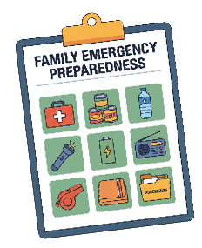
Nonperishable food
Clothing
Flashlight
First aid kit
Items for your pets
Blankets
Water
Extra batteries
For more information: www.ready.gov/kit

Sustainable Sammamish: renewable energy programs
April is Earth Month, and a great time to think about the environment. By making decisions that positively impact the health of our ecosystems and community, we can work together to support the environment that supports us. Puget Sound Energy has programs to help you do it!

Does enrollment in a renewable energy program really make a difference?
Yes! Your enrollment increases the amount of power generated from renewable resources by reducing dependence on fossil fuels and helping to build/buy a wider range of renewable energy sources in our region. The City encourages people to sign up for these programs to help achieve the City’s GHG reduction goals. These programs also support the local economy by helping to create green jobs in Washington and in the West.

Does PSE profit from these programs?
No, PSE does not profit from renewable energy programs. The City is partnering with PSE on a green power campaign that supports local renewable energy sources and reduces GHG emissions. If we meet our target, PSE will award the City $10,000 toward a community solar array.
Not interested in Green Power or Community Solar?
Learn more about what you can do to support sustainability in Sammamish at Sammamish.us/Sustainability. 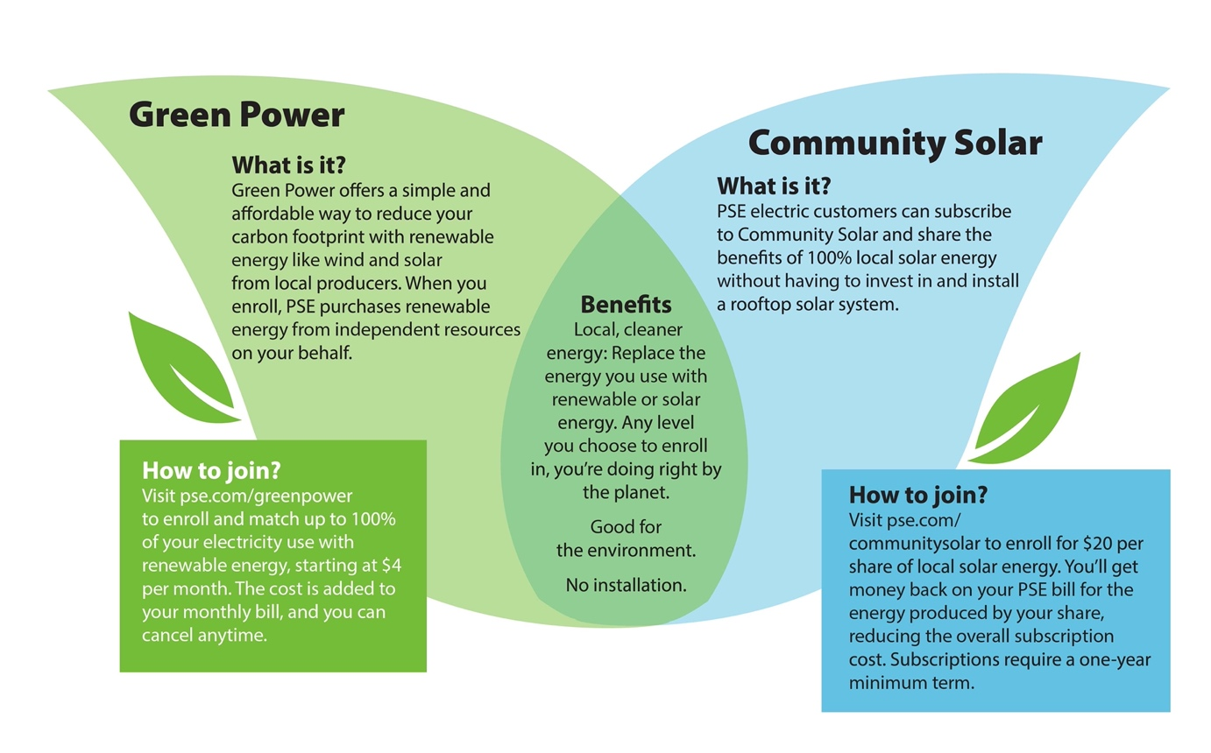

Green Power- What is it?
Green Power offers a simple and affordable way to reduce your carbon footprint with renewable energy like wind and solar from local producers. When you enroll, PSE purchases renewable energy from independent resources on your behalf.

How to join?
Visit pse.com/greenpower
to enroll and match up to 100% of your electricity use with renewable energy, starting at $4 per month. The cost is added to your monthly bill, and you can cancel anytime.

Community Solar - What is it?
PSE electric customers can subscribe to Community Solar and share the benefits of 100% local solar energy without having to invest in and install a rooftop solar system.

How to join?
Visit pse.com/communitysolar to enroll for $20 per share of local solar energy. You’ll get money back on your PSE bill for the energy produced by your share, reducing the overall subscription cost. Subscriptions require a one-year minimum term.

Benefits

Local, cleaner energy: Replace the energy you use with renewable or solar energy. Any level you choose to enroll in, you’re doing right by the planet.
- Good for the environment.
- No installation.
Sammamish Parks 101– Beaver Lake Park
Over the years, our parks have grown and evolved—adding new recreational opportunities while continuing to protect the green spaces our community loves most. Now, we’re excited to launch Sammamish Parks 101, a fun and educational campaign that takes a look back at where it all began. Through stories, milestones, and a few great throwback photos, we’ll explore the history of our parks and celebrate how far they’ve come. Join us as we revisit the past and rediscover the places that bring our community together!
First up...Beaver Lake Park.
Beaver Lake Park is 83 acres. It began as a private resort in the 1930s known as the Four Seasons Resort or Bartel’s Resort. The resort was sold in 1950s and was renamed Andy’s Beaver Lake Resort.
In 1960, the resort was sold to the Catholic Archdiocese of Seattle. The Catholic Youth Organization used it to run Camp Cabrini until 1985. Then King County purchased the site now known as Beaver Lake Park. The park was transferred from King County to the City of Sammamish in 2003.

Fun fact:
Clint Eastwood taught lifeguard training classes at the National Red Cross Aquatic School held at Beaver Lake the summer of 1953.
This park offers:
3 sports fields
A playground
Lodge & Pavilion
Off-leash dog park
Life jacket program
Restrooms

Save the date for upcoming Parks events

Big Rigs on the Plaza
May 16 @ Sammamish City Hall
11 a.m. – 2 p.m.

4th on the Plateau
July 4 @ the Sammamish Commons
5 p.m. –10 p.m.

Concerts in the Park
July 9 – Aug. 13
@ Pine Lake Park 6:30 – 8 p.m.

Kids First
July 7 – Aug. 18, Every Tuesday
@ City Hall Plaza
1 – 2 p.m.

Shakespeare in the Park
July 24 @ Klahanie Park, 7 p.m. – 9 p.m.

Join us for Big Rigs on the Plaza, May 16, at Sammamish City Hall, 11 a.m. – 2 p.m.

How to Get Information & Get Involved

Sammamish City Council Meetings
Regular city council meetings are held on the first Tuesday and third Tuesday of each month at 6:30 pm, with a study session on the second Tuesday at 6:30 pm. For agendas, minutes, and meeting videos, go to sammamish.us/citycouncil. To contact the Sammamish City Council,
email citycouncil@sammamish.us.

Sammamish Planning Commission
Sammamish Planning Commission meetings are held on the first and third Thursdays of each month at 6:30 pm. For agendas, minutes, and meeting videos, go to samammish.us/planningcommission. To contact the Sammamish Planning Commission, email planningcommission@sammamish.us.

Additional Public Meeting Information
Stay informed on city government with CivicWeb Portal. See a schedule of meetings, get meeting agendas, and view past meetings at sammamishwa.civicweb.net

Receive Email and Text Alerts
To subscribe to the City of Sammamish email updates and text alerts go to sammamish.us/subscribe.

City Newsletter
Suggestions or concerns? Contact
communications@sammamish.us

Follow City of Sammamish on Social Media
Scan the QR code or visit us at www.sammamish.us

RESOURCES FOR SAMMAMISH RESIDENTS
Police/Fire Emergency 911
Police Non-Emergency (206) 296-3311
Eastside Fire & Rescue (425) 313-3200
King County Sheriff (206) 263-9133
King County Animal Control (206) 296-7387
Garbage - Republic Services (425) 646-2400
Sammamish Permit Center (425) 295-0531
Sammamish Plateau Water and Sewer (425) 392-6256
NE Sammamish Water and Sewer (425) 868-1144

