Sammamish City Council
  - Council Meetings
Regular council meetings are held on the first Tuesday and third Tuesday of each month at 6:30 p.m., with a study session on the second Tuesday at 6:30 p.m. For more information, go to sammamish.us/citycouncil.
To contact the Sammamish City Council, email citycouncil@sammamish.us.
  - Coffee with Council
Join us for a cup of coffee and conversation. Coffee with Council happens the first Saturday of every month with rotating councilmember attendance. Meet them at 9:30 a.m. at Metropolitan Market in Sammamish. The councilmembers may be in the outdoor seating area depending on the weather conditions. Otherwise, you will find them in the upstairs seating area near the café. We hope to see you there!
Michael Boyer
Councilmember

Josh Amato
Mayor

Amy Lam
Councilmember

Roisin O’Farrell
Councilmember

Debbie Treen
Deputy Mayor

Kent Treen
Councilmember

Pamela Stuart
Councilmember

Meet Mayor Amato
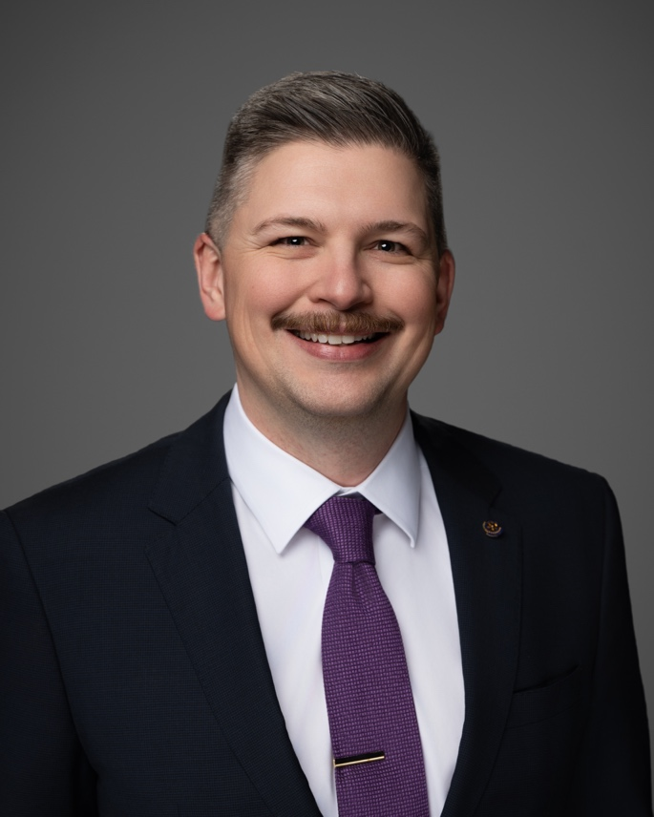
Since joining the City Council in January, Mayor Amato has been focused on one thing: creating a government that delivers results and works for the people who live here.
His journey to Sammamish began during a house-hunting trip with his wife.
“We immediately fell in love with the connection to nature, the big trees, and the amazing parks and open spaces,” he said.
After moving to Sammamish, he joined the Rotary Club and served four years on the
Planning Commission. His leadership in both roles helped prepare him to be Mayor.
As Mayor, he is advocating for projects that offer measurable improvements for residents today with a focus on transportation projects that decrease traffic and finding ways to fix the City’s structural budget imbalance–all with community involvement.
“To balance the budget, I want a process that gives residents the opportunity to provide real feedback on if they would rather see service cuts, tax increases to maintain services, or a mix of both,” he said. “If we need new taxes, I want them explained clearly so residents know exactly what they are paying for and why.”
Looking toward the next decade, the Mayor envisions a city that continues to celebrate its unique features among its Eastside neighbors.
“I want a city that honors and protects the natural environment while creating more opportunities for our community to connect and small businesses that enrich lives to thrive,” he said.

East Sammamish Park upgrades coming soon
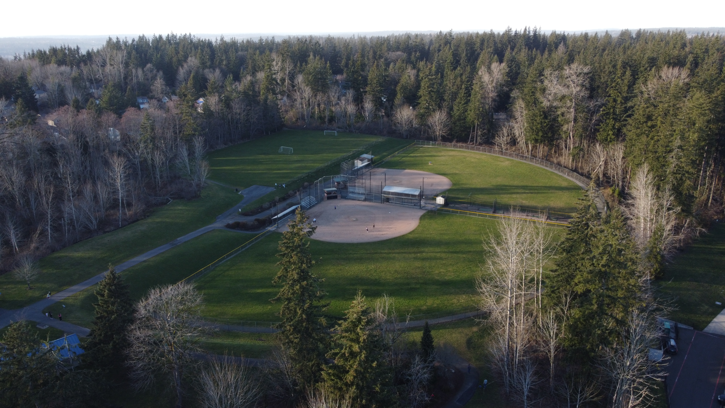
East Sammamish Park will undergo planned upgrades, marking the first major renovation since the park was built in the early 1990s. Construction is expected to start in July and is anticipated to be completed in September.
During construction, the pickleball/tennis courts will remain open for public use and parking will be available. However, the playground, shelter, restroom, and multipurpose field will be temporarily closed. A temporary restroom will be provided at the north of the tennis/pickleball courts.
The improvements will include new synthetic turf infields; minor ADA accessibility upgrades between the fields and the entry area; and resurfacing the batting cages with synthetic turf.
These upgrades are designed to improve accessibility and usability of the park while enhancing the overall experience for the community.
To stay up to date on where we are in the process, please visit the project website at https://www.sammamish.us/projects/east-sammamish-park-field-improvements/

Celebrate Pride Month at the June 24 Farmers Market
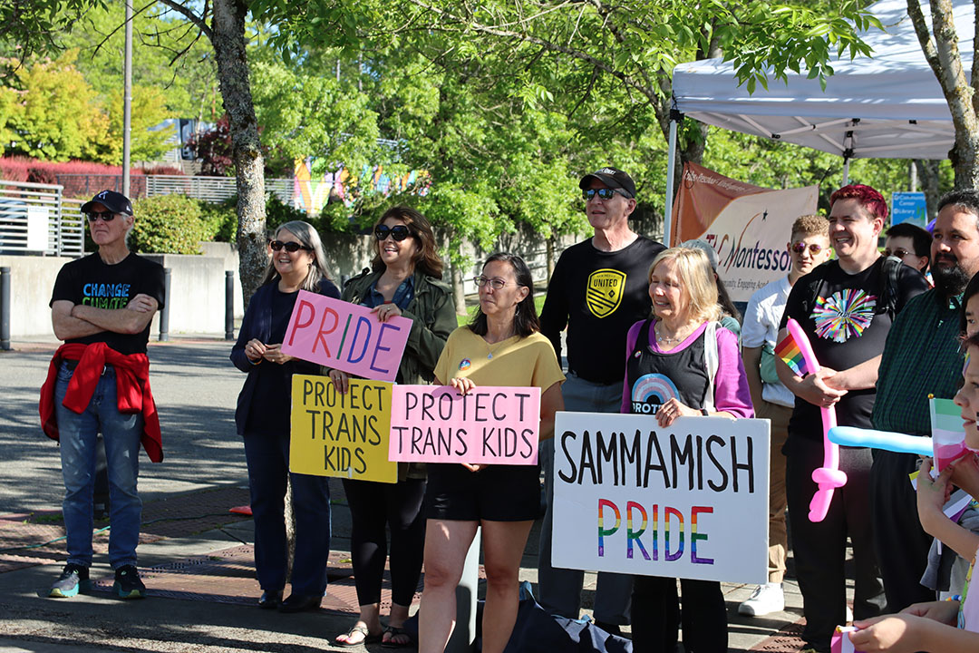
June 24, 2026 Market Start Time: 4 p.m., Pride Celebration Start Time: 5:30 p.m. Sammamish Commons (between City Hall and the Library) Join us for a special evening as we celebrate Pride Month at the Farmers Market on June 24, starting at 4 p.m. Come enjoy fresh, local produce, delicious food, and unique crafts from the wonderful vendors.
The celebration will kick off at 5:30 p.m. with a small event dedicated to honoring and supporting the LGBTQIA+ community. There will be live music, inspiring speakers, and fun activities for all ages.
Bring your friends and family, and join us in celebrating love, diversity, and community!

Save the date National Night Out returns Aug. 4
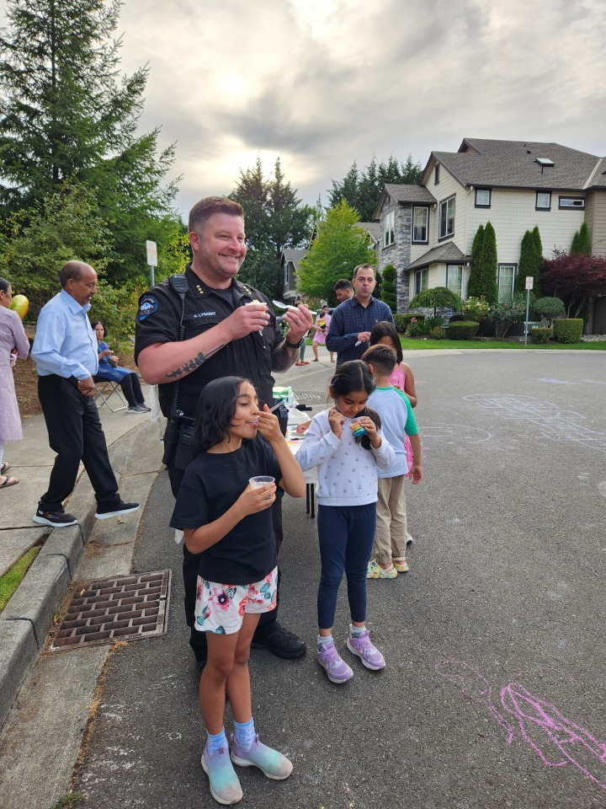
National Night Out is a national community-building campaign that promotes police-community partnerships. Millions of neighbors take part in National Night Out across thousands of communities in the U.S.
Neighborhoods host block parties, cookouts, etc and invite emergency personnel to stop by and get to know the community.
This year’s National Night Out is Aug. 4. Gatherings usually start around 4 or 5 p.m. and go into the evening. Registration will open July 1. If your block, or neighborhood wants to host a gathering, please visit our website for more information: https://www.sammamish.us/government/police/national-night-out/

The Sammamish Farmers Market
The Sammamish Farmers Market is back for the 2026 season brought to you by the Sammamish Chamber of Commerce and City of Sammamish, bringing fresh produce, local goods, and community connection to the Sammamish Commons.
We celebrated opening day with the traditional cowbell ringing and some words from the Chamber of Commerce and its partners.
The Farmers Market will run every Wednesday from May through September, 4–8 p.m. Shop from a diverse lineup of local farmers, artisans, and food vendors. Each week also features live entertainment, and special themed market days throughout the season.
Market hours will shift to 4 –7 p.m. on Sept. 2 and Sept. 9 due to earlier sunset times.
  - 2026 Special Event Days:
May 6 Opening Day
May 20 Youth Business Day
June 17 Soccer Fest
June 24 Pride Day
July 1 Children’s Business Fair
July 8 Nonprofit Day
July 15 Stay Healthy Day
August 5 Sustainable Sammamish
September 2 Welcome Week “Cultural Day”

City Council Discusses Budget and Financial Sustainability
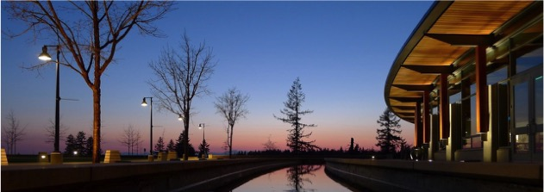
The City of Sammamish kicked off development of its 2027 and 2028 budget, which includes funding for City programs, services, and infrastructure. The City is still facing a long-term structural budget imbalance and is discussing options on how to fix the gap.
  - The structural imbalance
The City is currently facing a structural imbalance in its General Fund (operating) budget. This is a common challenge for cities across Washington that results from ongoing expenses growing faster than ongoing revenues. While property tax is the City’s largest revenue source, state law caps its growth at 1% per year plus new construction. Meanwhile, the costs of essential services like police, fire, and personnel rise at a much higher rate, primarily due to inflation. This means the City will need to make decisions about whether to increase funding, reduce expenditures (i.e., services), or find a balance between the two in order to remain financially sustainable.
The City convened a taskforce of ten community members in 2023 to review its finances and develop recommendations for maintaining financial sustainability . The City Council is currently reviewing those recommendations, along with other potential options, and is seeking community input.
  - Transparent approach to budgeting
The City Manager and staff are in the process of building a 2027-2028 budget proposal for Council’s review in the fall. For the first time, the budget will be organized around programs, such as public safety, arts, engineering, and more, to improve transparency for the public. Currently the budget is organized by department, which lacks detail for residents wanting to understand the full cost of services.
In addition, the new budgeting process will clearly identify ongoing costs from one-time costs, which are not currently readily available. This is a critical piece as the City identifies a path toward long term financial sustainability.
The budget proposal goes to City Council in early September. This timeline provides the Council with two to three months of rigorous review and allows time for public hearings before the budget is adopted by the end of 2026. Throughout this period, the Council will be discussing financial sustainability to ensure that any necessary changes are included in the adopted budget.
Please visit the City’s website to find the latest information on the budget and financial sustainability. www.sammamish.us/projects/2027-2028-budget/

The Community Pulse: We want to hear from you!
The City of Sammamish wants to hear your feedback. Complete this edition of the Community Pulse to let City officials know your thoughts on the City’s long-term financial sustainability, which can be found on the next page.
Scan the QR code below or visit: https://sammamish.jotform.com/261247372378059
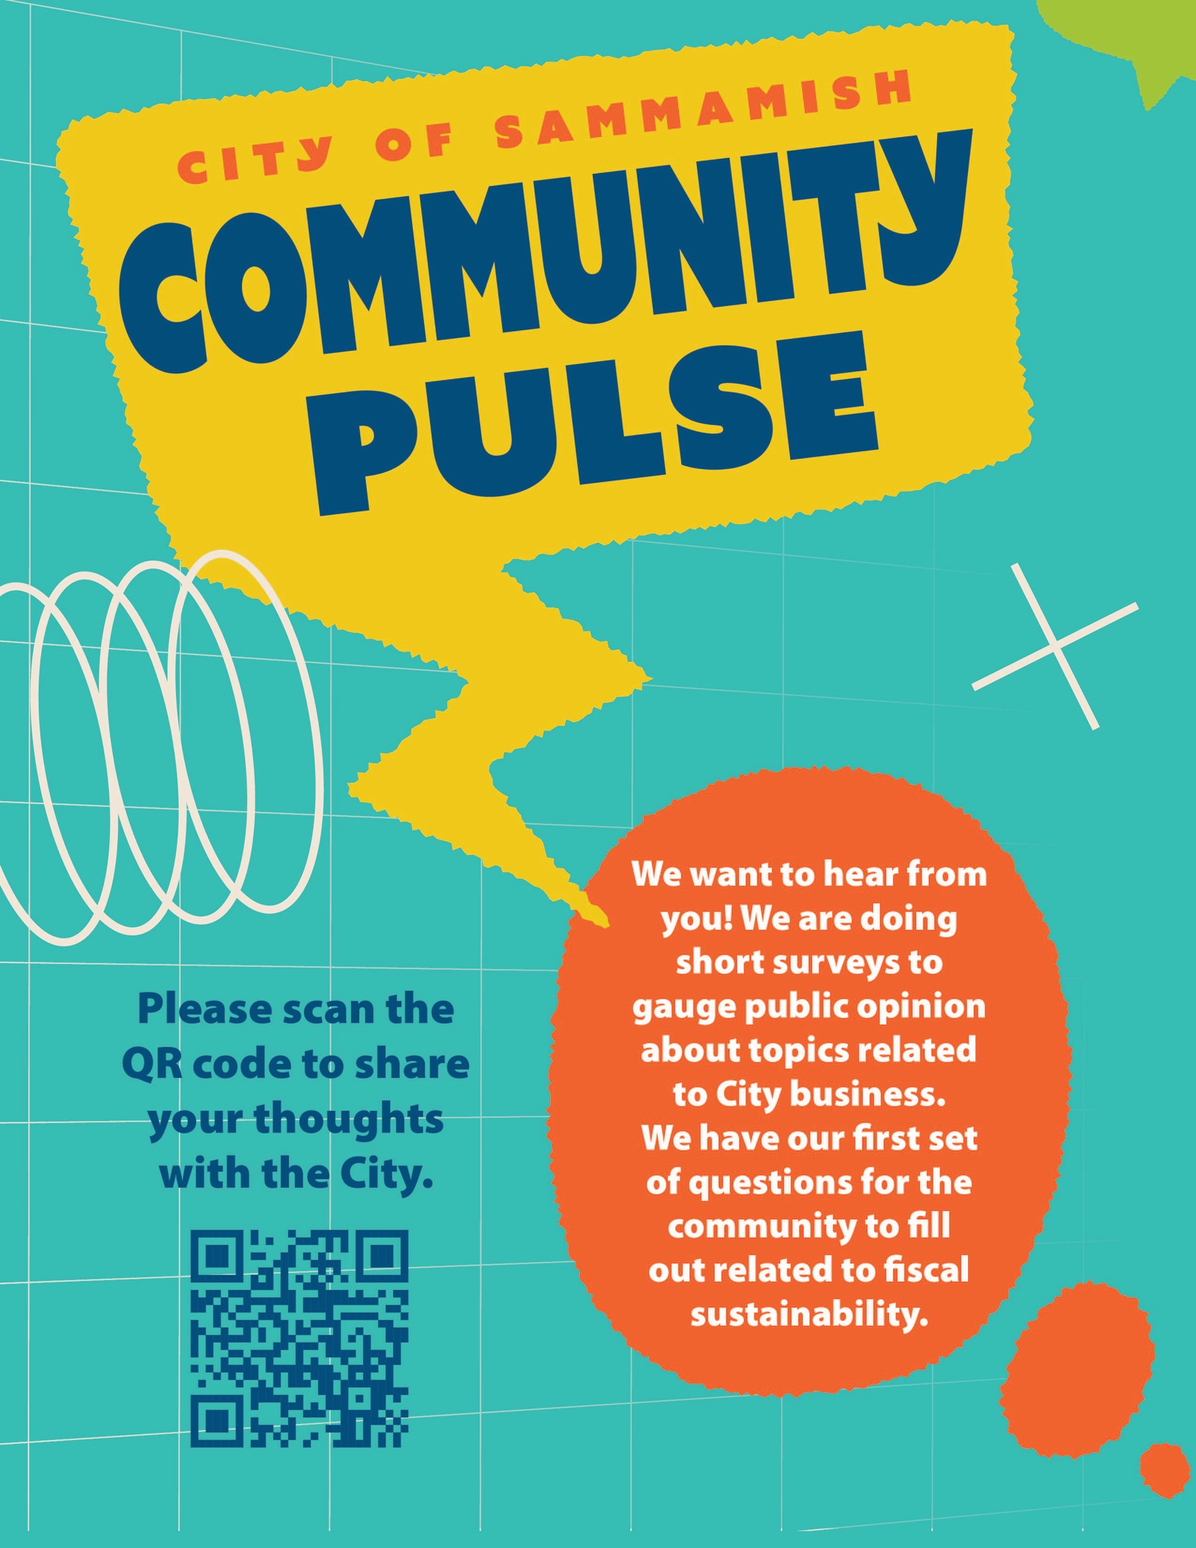

NPDES Stormwater Permit Update
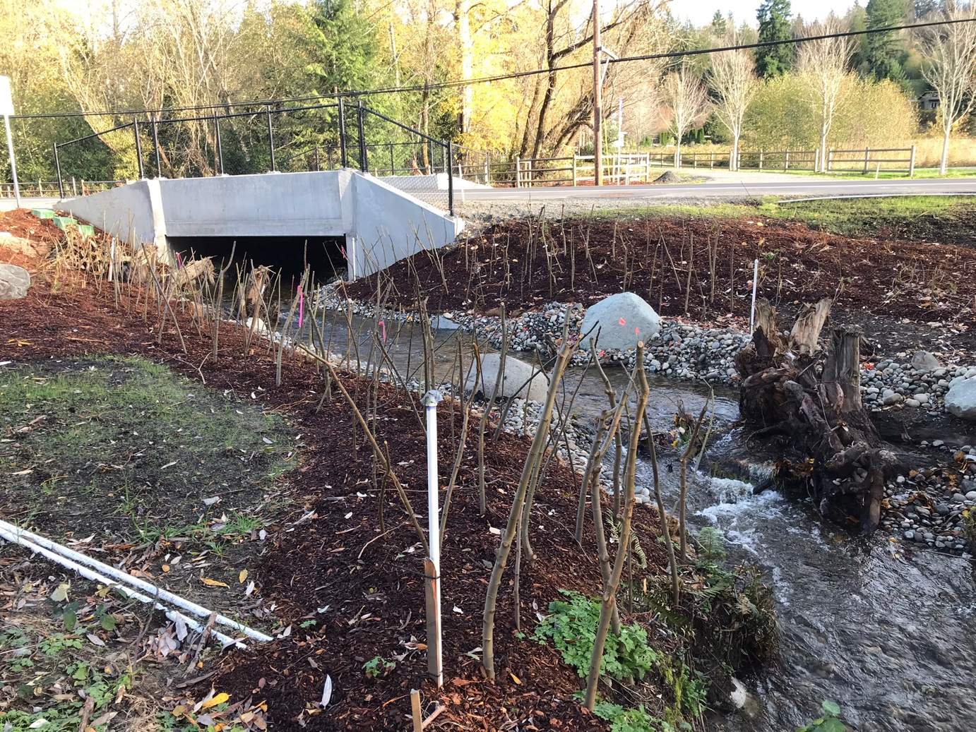
The National Pollutant Discharge Elimination System (NPDES) Western Washington Phase II Municipal Stormwater Permit, issued by the Department of Ecology, requires that all affected municipalities, including Sammamish, to annually update their Stormwater Management Program document (SWMP) and complete an annual report outlining the status of the city’s compliance with the permit requirements.
The Stormwater Management team has completed the 2026 update to the SWMP, which describes the City’s existing stormwater programs, as well as the plan to update and modify these programs as necessary to meet future requirements of the permit. The Stormwater team has also submitted the 2025 Annual Report to the Department of Ecology, which is due every March 31.
Both of these documents are available for public review and comment on the city’s Stormwater webpage https://www.sammamish.us/government/public-works/stormwater/npdes-stormwater-permit/

Evans Creek Preserve loop trail opens
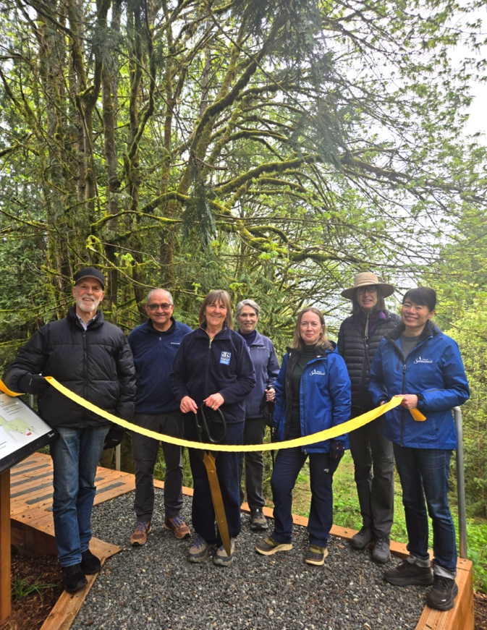
Deputy Mayor Treen and Councilmembers Lam and O’Farrell joined Parks and Recreation Commissioners, consultants, staff, and community partners to celebrate the opening of a new loop trail at Evans Creek Preserve on April 23. The completion of this loop trail marks the first step in expanding public access to the Preserve.
This effort reflects more than three years of collaboration among City staff, consultants, and volunteers, whose thousands of hours supported trail construction and restoration. The .83 mile loop trail, now open to the public, is a pedestrian-only path designed to follow the natural contours of the landscape. It provides a sustainable, low impact route that minimizes environmental disturbance while allowing visitors to explore this forested open space within the City.
The loop trail is the first phase of a larger project that will connect the northern portion of the Williams Pipeline Trail to Evans Creek Preserve, advancing a priority identified in the City’s 2024 Parks, Recreation, and Open Space Plan. Once Phase 2 is complete, the project will add a third access point to Evans Creek Preserve for pedestrians only, complementing the two existing vehicular entrances from Sahalee Way and SR 202.

City to pursue new, accessible website
City Council gave direction to staff to pursue a new website vendor to support an accessible City website that complies with the Web Content Accessibility Guidelines (WCAG) as mandated by the federal government.
The City’s current host, Umbraco, is not fully formatted to allow for assistive technology, which people with disabilities use to gain access to information. Digital accessibility standards continue to evolve and a new website platform will allow the City to better meet modern WCAG requirements. The City will seek public bids from companies that can meet the new compliance measures this spring.
The WCAG guidelines will also impact how the City provides content across other communications channels as well, including social media and our printed newsletter.
Complying with the WCAG helps ensure that everyone can access important City information, services, and programs online, regardless of ability or the technology they use. These guidelines also impact documents, photos, and videos shared online.
The federal Department of Justice extended the deadline for entities serving populations over 50,000 people. The new compliance deadline is April 2027. The City is beginning to make changes to the content that is shared on social media and will make additional changes to video and other content. The City will still move forward with a new website to meet compliance by the 2027 date.
To learn more about the WCAG requirements, visit: https://www.ada.gov/resources/web-rule-first-steps/ Watch the full Council presentation: https://www.youtube.com/watch?v=3pu2xsp7NME

Water safety 101
Water competency is a way of improving water safety for yourself, your family, and those around you. Here are some helpful tips to avoid common dangers, make you safer, and prevent drowning emergencies.
Water Smarts- When you are around water, take sensible precautions, even if you do not plan to swim.
  - This includes:
- Know your limitations, including physical fitness, swimming ability, and medical conditions
- Always swim with lifeguards or someone watching you, and wear a life jacket that is appropriate for your size and weight
Helping Others: These actions will help your family avoid emergencies and help you respond during an emergency
- Pay close attention to children or weak swimmers you are supervising in or near water
- Know the signs that someone is drowning
- Know ways to safely assist a drowning person
- Learn CPR and First Aid
Don’t forget, we offer a Life Jacket Loaner Program at Pine Lake and Beaver Lake Parks!

CPR can save lives
Performing CPR is hard. In a life-or-death situation, most of us struggle just to keep our composure. The rhythm of chest compressions should remain within the 100-120 beats per minute (BPM) range.
Here are five songs to help you stay on target:
- “Dynamite” by BTS
- “Another Bites the Dust” by Queen
- “Golden” by HUNTR/X from KPOP Demon Hunters
- “Respect” by Aretha Franklin
- “Just Dance” by Lady Gaga
Learn about CPR training from King County:
https://kingcounty.gov/en/dept/dph/health-safety/health-centers-programs-services/emergency-medical-services/community-programs/cpr-education

Sustainable Sammamish: Ride with Community Van!
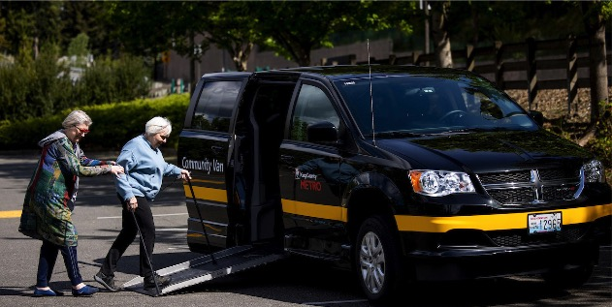
You may have seen the multicolored Metro Flex vehicles driving around town, but did you know there is another King County Metro travel option available for Sammamish residents?
Community Van is a volunteer-driven transportation service, driven for the community by the community. This program is designed to provide residents with customized options for getting around when bus routes don’t meet your needs.
  - How to Ride
- Submit a trip request: Via email, phone call, text, or online form. Minimum two business days’ notice.
- Volunteer match: Your trip is matched with a pool of vetted and trained volunteer drivers in the area to determine availability. The sooner a trip is requested the more likely it is to be accepted.
- Ride: Receive a confirmation and be connected to a driver.
Community Van trips are coordinated by our partners at Hopelink and open to everyone regardless of age, income, or ability. There is no application process required.
For more information on transportation options in Sammamish, please visit: www.sammamish.us/our-community/getting-around
  - Program Information
- At least two riders are required to schedule a trip.
- The standard Metro fare covers a round-trip in the Community Van, which is $3.00 for adults. Youth 18 and under ride free!
  - Pay with Transit GO mobile tickets, any monthly ORCA card, or Human Services Bus Tickets.
  - Metro provides the driver training, gas, insurance, and maintenance.
- Accessible options
  - 6-passenger wheelchair accessible vans with ramp
  - 7-passenger and 12-passenger vans (not wheelchair accessible)
- Required accessibility training for all drivers

Sammamish Parks 101–Ebright Creek Park
  - a home to Kokanee salmon
Did you know Sammamish’s parks have stories as rich as their landscapes? In our Sammamish Parks 101 series, we explore the history, growth, and hidden gems of our local parks—while revisiting some fun photos along the way.
Parks 101 is your guide to discovering (and rediscovering) the spaces that make Sammamish special. Let’s talk about Ebright Creek Park!
Ebright Creek Park spans 12 acres and features three unique areas. Ebright Creek is one of the few known spawning areas for the Kokanee salmon!
Ebright Creek flows between the middle and back sections. The back section of the park offers a quiet meadow, small loop trail and some benches. Purchased in 2001, the park officially opened in 2007. Ebright Creek Park was the first park the City of Sammamish designed and opened after incorporation.
This park offers:
- A playground
- Picnic Shelter
- Restrooms
- Basketball Courts
- Tennis Courts
- Trails

Community repair event, can help you fix household items
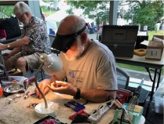
Sunday, July 26 1:30-4:30 p.m. at Sammamish Library, 825 228th Ave. SE At this King County free community repair event at the Sammamish Library, skilled volunteer “fixers” will try to repair and mend household items and clothing!
First-come, first-served. If people bring second items, fixers will try to get to those after they’ve worked on everyone’s first items. Visit KingCounty.gov/repair-events to learn more.
If you’re not sure if your item is a good fit for these events, or if you have any other questions, please contact event coordinator Tom at tom.watson@kingcounty.gov or at 206-477-4481.

Please join us for 4th on the Plateau
Saturday, July 4 from 5-10 p.m. Fireworks start at 10 p.m. Enjoy live music, delicious food from food trucks, and of course vibrant fireworks. The event spreads from Lower common park to City hall plaza.

How to Get Information & Get Involved

Sammamish City Council Meetings
Regular city council meetings are held on the first Tuesday and third Tuesday of each month at 6:30 pm, with a study session on the second Tuesday at 6:30 pm. For agendas, minutes, and meeting videos, go to sammamish.us/citycouncil. To contact the Sammamish City Council,
email citycouncil@sammamish.us.

Sammamish Planning Commission
Sammamish Planning Commission meetings are held on the first and third Thursdays of each month at 6:30 pm. For agendas, minutes, and meeting videos, go to samammish.us/planningcommission. To contact the Sammamish Planning Commission, email planningcommission@sammamish.us.

Additional Public Meeting Information
Stay informed on city government with CivicWeb Portal. See a schedule of meetings, get meeting agendas, and view past meetings at sammamishwa.civicweb.net

Receive Email and Text Alerts
To subscribe to the City of Sammamish email updates and text alerts go to sammamish.us/subscribe.

City Newsletter
Suggestions or concerns? Contact communications@sammamish.us

Follow City of Sammamish on Social Media
Scan the QR code or visit us at www.sammamish.us

RESOURCES FOR SAMMAMISH RESIDENTS
Police/Fire Emergency 911
Police Non-Emergency (206) 296-3311
Eastside Fire & Rescue (425) 313-3200
King County Sheriff (206) 263-9133
King County Animal Control (206) 296-7387
Garbage - Republic Services (425) 646-2400
Sammamish Permit Center (425) 295-0531
Sammamish Plateau Water and Sewer (425) 392-6256
NE Sammamish Water and Sewer (425) 868-1144

